Object-Oriented Programming (OOP) Languages

📌 Definition:
# Source: AI Source: Provided by: [Data Path: Persons Table -> ID Column: 1, Name_En Column: Motasem Essam] -> From: [Chatgpt (GPT‑5 Mini)] on [12/9/2025]
Object-Oriented Programming (OOP) is a type of high-level programming where programs are built using objects and classes that combine data and behavior.

🧠 Simple idea:
# Source: AI Source: Provided by: [Data Path: Persons Table -> ID Column: 1, Name_En Column: Motasem Essam] -> From: [Chatgpt (GPT‑5 Mini)] on [12/9/2025]
OOP = Objects that contain data + actions

🔍 Key concepts (4 pillars of OOP):
# Source: AI Source: Provided by: [Data Path: Persons Table -> ID Column: 1, Name_En Column: Motasem Essam] -> From: [Chatgpt (GPT‑5 Mini)] on [12/9/2025]
- 🧱 Encapsulation → bundling data + methods together
- 🧬 Inheritance → reuse code from other classes
- 🎭 Polymorphism → same action, different behavior
- 🔒 Abstraction → hide complex details

🧩 Example:
# Source: AI Source: Provided by: [Data Path: Persons Table -> ID Column: 1, Name_En Column: Motasem Essam] -> From: [Chatgpt (GPT‑5 Mini)] on [12/9/2025]
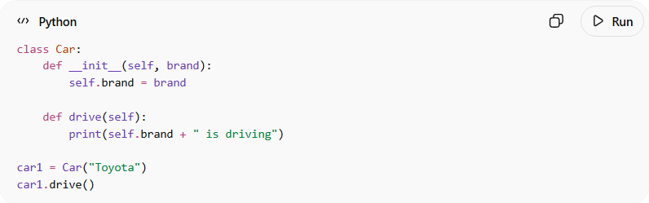
class Car:
def __init__(self, brand):
self.brand = brand

def drive(self):
print(self.brand + " is driving")

car1 = Car("Toyota")
car1.drive()
👉 Here:
- Car = class
- car1 = object
- brand = data
- drive() = behavior

⚙️ How it works:
# Source: AI Source: Provided by: [Data Path: Persons Table -> ID Column: 1, Name_En Column: Motasem Essam] -> From: [Chatgpt (GPT‑5 Mini)] on [12/9/2025]
- Define a class (blueprint)
- Create objects from it
- Use objects to access data and functions

🧩 Examples of OOP languages:
# Source: AI Source: Provided by: [Data Path: Persons Table -> ID Column: 1, Name_En Column: Motasem Essam] -> From: [Chatgpt (GPT‑5 Mini)] on [12/9/2025]
- Java ☕
- C++
- Python 🐍
- C#

🆚 OOP vs Procedural
# Source: AI Source: Provided by: [Data Path: Persons Table -> ID Column: 1, Name_En Column: Motasem Essam] -> From: [Chatgpt (GPT‑5 Mini)] on [12/9/2025]
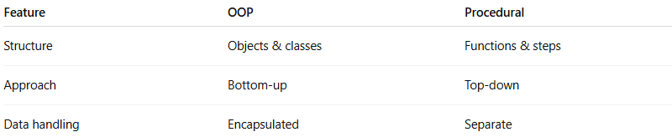
Feature | OOP | Procedural
Structure | Objects & classes | Functions & steps
Approach | Bottom-up | Top-down
Data handling | Encapsulated | Separate

✅ Summary:
# Source: AI Source: Provided by: [Data Path: Persons Table -> ID Column: 1, Name_En Column: Motasem Essam] -> From: [Chatgpt (GPT‑5 Mini)] on [12/9/2025]
OOP organizes software around objects that combine data and behavior, making programs more reusable, scalable, and easier to maintain.

